CO1301: Games Concepts
Week 19: Rotation

Introduction
- This worksheet will introduce the idea of using matrices to rotate the models. Make sure that you have finished the worksheet from week 19 before attempting this worksheet since it relies upon understanding the idea of the matrix associated with each model.
- The worksheet uses floating point arrays to represent the models. The exercises also use functions. If it is not apparent what the functions and arrays are doing them ask me to explain.

Exercise 1: Rotation about the world x-axis
- Load the cube mesh.
- Create a box model at location ( 0, 0, 0 ).
- Define a constant called kPi for π.

const float kPi = 3.1415926f;

- Each model has a 4x4 matrix associated with it. The matrix for a model in obtained using the GetMatrix() method. The following code gets the matrix of box and places it into the 4x4 array:

float matrix[4][4];
box->GetMatrix( &matrix[0][0] );

- The matrix can be then be manipulated. After the matrix has been changed the new matrix can be assigned to the model using the SetMatrix() method. The following code sets the matrix of box:

box->SetMatrix( &matrix[0][0] );

- The first row of the matrix is local x-axis:
  - matrix[0][0] is the x component of the x-axis
  - matrix[0][1] is the y component of the x-axis
  - matrix[0][2] is the z component of the x-axis
- The second row of the matrix is local y-axis.
- The third row of the matrix is local z-axis.
- The following function will rotate a model around the world x-axis and the local origin of the model.

// Rotate around the World x-axis and the local origin.
// float rotation : angle to rotate in degrees
// matrix[4][4] : model to be rotated
void rotateX( float matrix[4][4], float rotation )
{
// convert the rotation from degrees to radians
float alpha = rotation * kPi / 180.0f;
// find the sine of the angle
float sinAlpha = sin( alpha );
// find the cosine of the angle
float cosAlpha = cos( alpha );

// Need to use temporary values because x and y get overwritten during the
// course of the calculations (only one is actually needed - see the maths
// classes in year 2, but the code is clearer this way)
float tempY;
float tempZ;

// Perform the minimum of calculations rather than use full matrix
// multiplication. A rotation around the world x-axis only causes the y
// and z components of each of the locals axes to be changed. See the
// worksheet and lecture notes.
// In this version of the rotation we want the coordinates of the model
// to be left unchanged so the final row is ignored.

// Firstly rotate the local x-axis (first row)
tempY = matrix[0][1] * cosAlpha - matrix[0][2] * sinAlpha;
tempZ = matrix[0][1] * sinAlpha + matrix[0][2] * cosAlpha;
matrix[0][1] = tempY;
matrix[0][2] = tempZ;

// Rotate the local y-axis (second row)
tempY = matrix[1][1] * cosAlpha - matrix[1][2] * sinAlpha;
tempZ = matrix[1][1] * sinAlpha + matrix[1][2] * cosAlpha;
matrix[1][1] = tempY;
matrix[1][2] = tempZ;

// Rotate the local z-axis (third row)
tempY = matrix[2][1] * cosAlpha - matrix[2][2] * sinAlpha;
tempZ = matrix[2][1] * sinAlpha + matrix[2][2] * cosAlpha;
matrix[2][1] = tempY;
matrix[2][2] = tempZ;
}

- Copy the function into your code and then use it to rotate the box.
- The code uses the Euler rotation matrix:
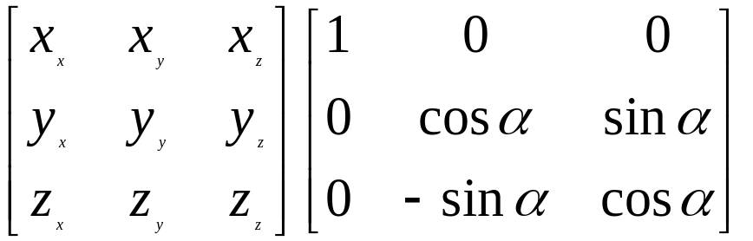

- Examine the code in conjunction with the rotation matrix. What is happening is that the matrix is being applied to each of the local axes in turn: first the local x-axis, then the local y-axis, and finally the local z-axis. Remember that the rows of the first matrix are combined with the columns of the second matrix. Pair up the components and multiply them together and then sum the result.
  - The result of applying the matrix to the local x-axis is that y and z components are changed.
  - The result of applying the matrix to the local y-axis is that y and z components are changed.
  - The result of applying the matrix to the local z-axis is that y and z components are changed.
  - The net effect is that column 1 and column 2 are changed.
  - We want to leave the position of the model unchanged and so the last row of the matrix can be ignored.

Exercise 2: Rotation about the world y-axis
- Using the existing code as your starting point, implement a rotation around the world y-axis.
- The appropriate matrix is:

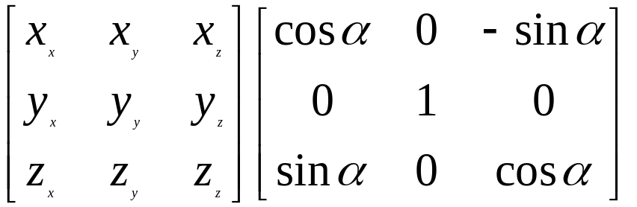

- Try to perform the matrix multiplication yourself. However, the net effect of the matrix will be:
  - The x and z components of the local x-axis are changed.
  - The x and z components of the local y-axis are changed.
  - The x and z components of the local z-axis are changed.
  - The net effect is that column 0 and column 2 are changed.
  - We want to leave the position of the model unchanged and so the last row of the matrix can be ignored.

Exercise 3: Rotation about the world z-axis
- Using the existing code as your starting point, implement a rotation around the world z-axis.
- The appropriate matrix is:

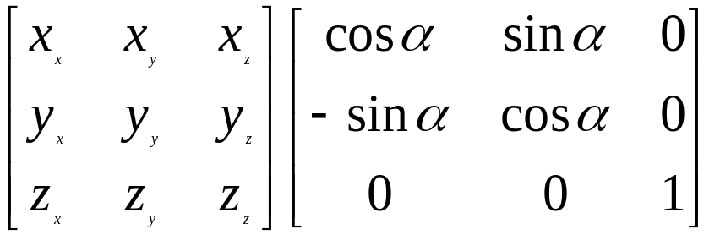

- Try to perform the matrix multiplication yourself. However, the net effect of the matrix will be:
  - The x and y components of the local x-axis are changed.
  - The x and y components of the local y-axis are changed.
  - The x and y components of the local z-axis are changed.
  - The net effect is that column 0 and column 1 are changed.
  - We want to leave the position of the model unchanged and so the last row of the matrix can be ignored.

Advanced: Changing the model position
- In all of the rotations carried out above the position of the model has been left unchanged. Using the existing code as your basis write a new rotatateX function that rotates the model around the world x-axis and rotates the position of the model around the x-axis at the same time.
- Now write new functions for the rotation around the world y-axis and z-axis which include model rotation as well.

